Critical Play with LLMs
Welcome and introductions (10 min)
- Name, pronouns, field, favorite game to play with family, friends, or students (5 min)
Live Jeopardy! prompting sequence (10 min)
- Simple category (accurate baseline)
- Obscure real category (mixed results)
- Fictitious category (confabulation trigger)
Debrief discussion (10 min)
- Game mechanics serve as analytical scaffolds that help reveal AI limitations in situ.
- For example: Jeopardy! format requires the LLM to generate coherent categories, sliding difficulty levels, and factual clues, making confabulation immediately visible when it fails
- Respond in chat: What games offer similar affordances in their ability to expose a large language model for the bullshit machine that it is?
Critical Play with Mary Flanagan (5 min)
Traditional Iterative Game Design Model
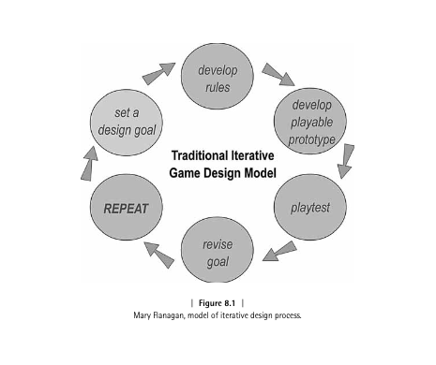

Playful interactions with LLMs (5 min)
Interrogating AI: Characterizing Emergent Playful Interactions with ChatGPT
- Reflecting
- Jesting
- Imitating
- Challenging
- Tricking
- Contriving
Frame companion worksheet (5 min)
Quick demo session (10 min)
- Set design goal for interacting w/ AI
- Create rules to constrain AI model in terms of familiar game logic
  - e.g. 20 questions, exquisite corpse, chess
- Crowdsource prompts that demonstrate types of playful interaction from earlier
Critical design activity (15 min)
- Design game to reveal AI limitations
- Leverage 2-3 types of playful interactions
- Shareback game design after 15 min:
  - system prompt
  - starter prompt(s)
  - optional settings
Playtest demo and comparison rounds (15 min)
Resources and Q&A (5 min)
BEGIN COMPANION WORKSHEET

ITP Lab | Critical Play with Large Language Models
Types of Playful Interactions with LLMs (via r/ChatGPT)
Type | What It Does | Try This
Reflecting | Prompting AI to self-represent and express “opinions” | Ask about self-understanding
Jesting | Generating humor and nonsensical exchanges | Request absurd combinations
Imitating | Requesting persona or character mimicry | Ask it to role-play
Challenging | Testing capabilities until failure | Push logical limits
Tricking | Attempting deception/boundary bypassing | Try jailbreak techniques
Contriving | Creating impossible or fabricated content | Request non-existent things
Choose a game format to experiment with:
☐ 20 Questions ☐ Exquisite Corpse ☐ Two Truths and a Lie ☐ Word Association ☐ Chess/Checkers Annotation ☐ Role Play Simulations ☐ Wordle ☐ Other:

Target AI Limitation:
☐ Hallucination/confabulation ☐ Logic inconsistency ☐ Context loss ☐ Bias/stereotypes ☐ Safety bypass ☐ Other:

What’s your design goal?
What do you want to reveal about AI abilities/limitations?
System Prompt
Set the stage and define AI’s role/constraints

Starter Prompt(s)
Initial prompts players would use
1.
2.
3.

Optional Settings (Advanced)
Temperature: ☐ 0 (very deterministic) through 1.5 (more creative)
Max Output: 50-1000 Tokens (equivalent to ¾ of one word)

Expected Outcomes
What do you predict will happen?

What failure modes might emerge?

How will game mechanics make limitations visible?

